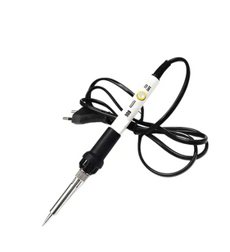60W Soldering Iron XCY 908 Adjustable 200-450 Degree celsius Temperature Control Hand tools High Insulated

Soldering Paste

NRF24L01+PA+LNA 2.4GHz SMA Antenna Wireless Transceiver communication module
